FT Cloud provides the following hot keys to make navigating the chart as quick as possible. These hot keys mirror the hot keys of FT4web. [Control key] – [action key]
General Hot Keys
- D – Open chart display panel (to change chart layout)
- U – Open parameters panel
- M – Search and Load family to list
- W – Bring cursor to start date
- SHIFT + 1 – Save J Chart composite line as FNU
- CTRL + Up Arrow / CTRL + Down Arrow – Navigate row selected on of list. The red color cell will show ticker of selected row
- F5 – Refresh Screen

Color Bar Hot Keys
- R – change RED color bar ticker
- G – change GREEN color bar ticker
- Y – change YELLOW color bar ticker. (Orange color box)
- M – change MAGENTA color bar ticker
- C – change CYAN color bar ticker
- B – change BLUE color bar ticker

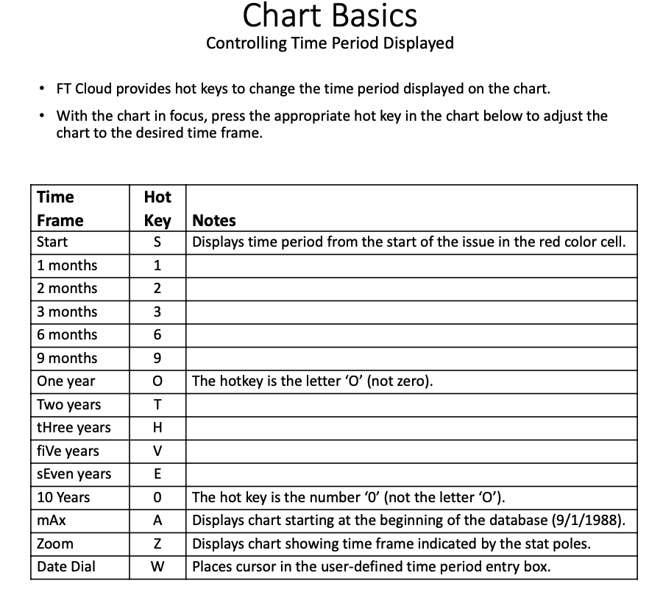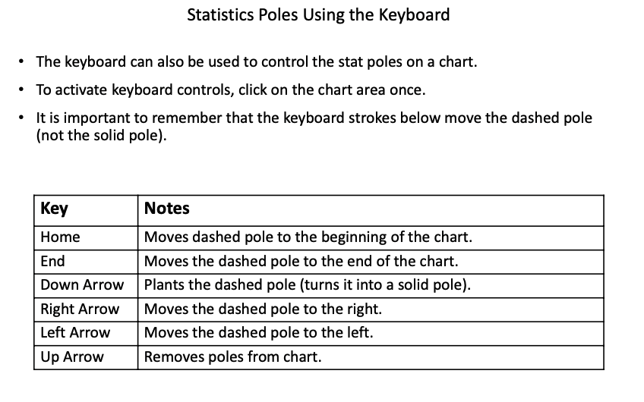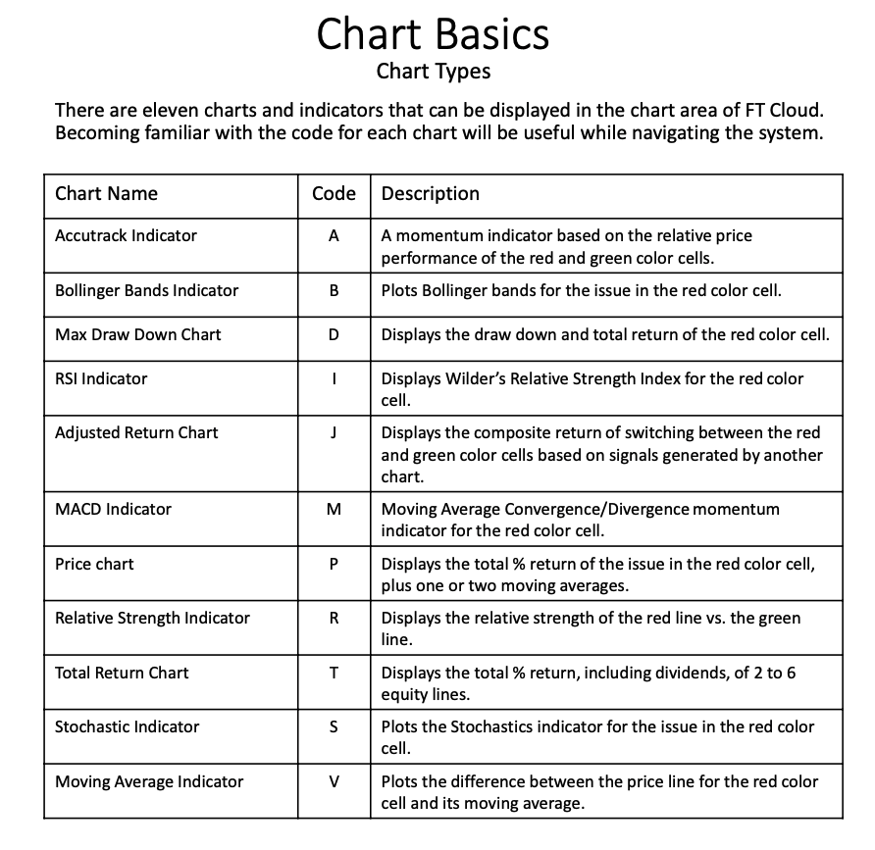
For MAC keyboards:

The “Home” button = [Fn] + [Left arrow]
The “End” button = [Fn} + (Right arrow]

